MLA0101-Artificial Intelligence and Expert Systems
CO1-Assessesment Tool2
Scenario Based Research Assessment

Name: M. Vaishnavi
Register No:192525051

Artificial Intelligence in Healthcare: AI-Assisted Medical Diagnosis Using Med-Gemini

1. Title of AI Application
AI-Assisted Medical Diagnosis Using Med-Gemini
Domain: Healthcare

2. Domain Selection
The selected domain is Healthcare. Artificial Intelligence is transforming pharmaceutical research by accelerating drug discovery, reducing development costs, and improving the success rate of new medicines. AI helps researchers identify promising drug candidates and predict their effectiveness more efficiently.
3. Introduction and Background
Med-Gemini is an advanced multimodal Artificial Intelligence system designed to process different types of medical information, including X-rays, CT scans, MRI images, laboratory reports, and patient history. It combines image analysis and language understanding to provide diagnostic suggestions. Rather than replacing doctors, it acts as an intelligent assistant that improves efficiency and enhances the quality of healthcare services

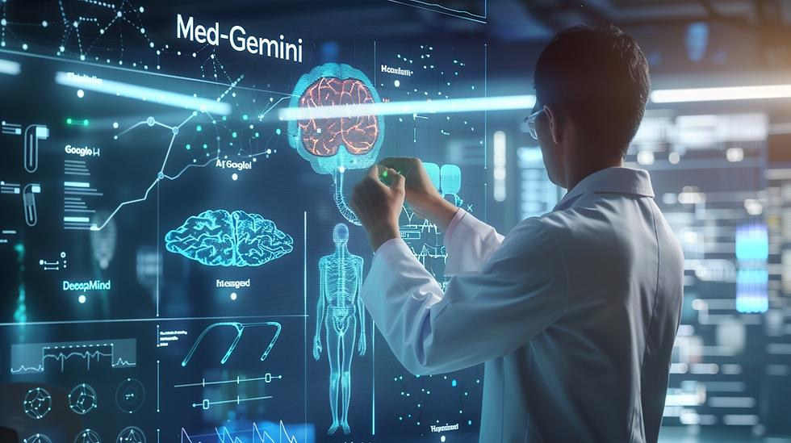

4. Problem Identification
Drug development faces several challenges such as:
- Long research and testing time.
- High development costs.
- Low success rate of clinical trials.
- Complex biological data.
- Difficulty in identifying suitable drug compounds.
These challenges delay the availability of new medicines.

5. Need for AI Solution
AI is required because it:
- Analyzes large biomedical datasets quickly.
- Identifies potential drug molecules.
- Predicts drug effectiveness and side effects.
- Reduces research time and costs.
- Improves clinical trial success.
- Supports personalized medicine.
Compared to traditional methods, AI provides faster and more accurate drug discovery.

6. AI Technologies Used
The system uses:
- Machine Learning (ML)
- Deep Learning (DL)
- Computer Vision
- Natural Language Processing (NLP)
- Generative AI
- Large Language Models (LLMs)
- Medical Image Analysis
- Neural Networks
These technologies enable the system to understand medical reports, X-rays, MRI scans, CT scans, and patient history.
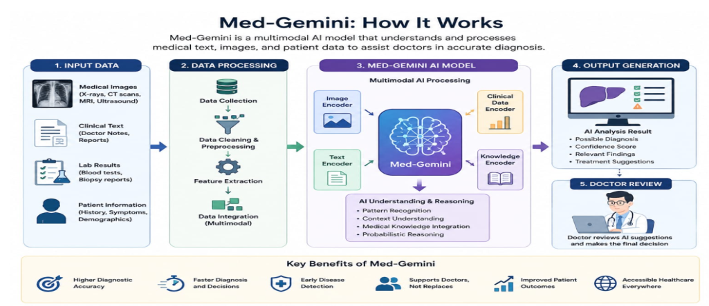

7. Working Mechanism

Step 1: Collect patient information, symptoms, medical history, laboratory reports, and medical images.
Step 2: Preprocess the data by removing noise and standardizing the information.
Step 3: Deep learning algorithms analyze medical images while NLP processes clinical text.
Step 4: AI compares the information with millions of medical records and trained models.
Step 5: The system predicts possible diseases and recommends suitable treatments.
Step 6: Doctors review the AI recommendations and make the final clinical decision

8. Data Sources and Processing
The AI system uses:
- Electronic Medical Records (EMR)
- X-ray images
- MRI scans
- CT scans
- Blood test reports
- Clinical notes
- Medical research databases
The collected data is cleaned, normalized, labeled, and processed using machine learning models before prediction.

9. Real-World Implementation
AI-assisted diagnosis is currently used by:
- Google DeepMind
- Mayo Clinic
- Cleveland Clinic
- Apollo Hospitals
- NHS (United Kingdom)
Applications include:
- Early cancer screening
- Brain disease diagnosis
- Heart disease detection
- Lung infection analysis
- Diabetic eye disease detection
10. Impact and Benefits
Benefits include:
- Faster diagnosis
- Higher accuracy
- Early disease detection
- Reduced healthcare costs
- Better patient monitoring
- Reduced workload for doctors
- Improved healthcare accessibility
- Better patient satisfaction

11. Challenges and Limitations
Challenges include:
- Patient data privacy
- Cybersecurity risks
- High implementation cost
- Requirement for quality medical datasets
- Ethical concerns
- AI bias
- Need for human supervision
- Regulatory compliance

12. Future Scope and Emerging Trends
Future developments include:
- Personalized AI treatment plans.
- Wearable AI health monitoring.
- AI-assisted robotic surgery.
- Digital twins for patients.
- Remote healthcare through AI.
- Improved multimodal AI systems.
- Faster disease prediction with advanced deep learning.
AI is expected to become an essential assistant for doctors rather than replacing them.

13. Conclusion
Artificial Intelligence is transforming healthcare by improving diagnosis, treatment planning, and patient care. Med-Gemini demonstrates how advanced AI technologies can support healthcare professionals with faster and more accurate clinical decisions. Although challenges such as privacy, ethics, and implementation costs remain, continuous research and technological advancements will make AI an indispensable tool in future healthcare systems.

14. References
- Google DeepMind. Med-Gemini: Advancing Multimodal Medical AI.
- World Health Organization (WHO). Ethics and Governance of AI for Health.
- IEEE Xplore Digital Library – AI in Healthcare.
- Nature Medicine – Artificial Intelligence in Clinical Practice.
- National Institutes of Health (NIH) – Artificial Intelligence in Medicine.
- Journal of Artificial Intelligence in Medicine.
- The Lancet Digital Health.
- Google Research – Healthcare AI.

